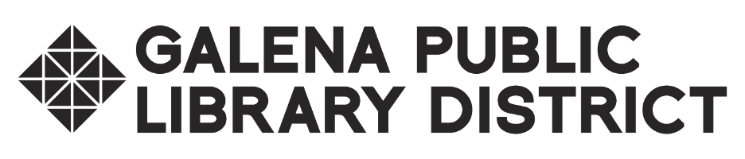

**Library Board of Trustees Meeting**

**Budget & Appropriation Hearing August 12, 2024 at 6:00pm**

**Galena Public Library - Historical Room**

**AGENDA**

1. Call to order, roll call
2. Review of Draft FY 2025 Budget & Appropriation
3. Adjournment
4. Next meeting - Monday, August 12, 2034 at 6:30pm, Galena Public Library, 601 S. Bench St., Galena, IL 61036 - Historical Room