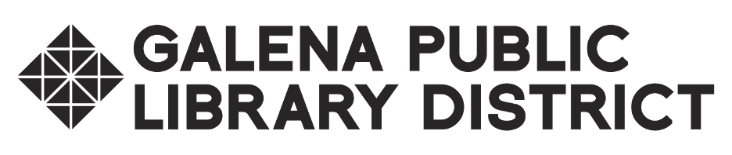

**Library Board of Trustees Meeting**

**Regular Meeting Monday, August 12, 2024 at 6:30pm**

**Galena Public Library - Historical Room**

**AGENDA**

1. Call to order, roll call
2. Citizen comments (3 minutes per person, 15 minutes total)
3. Consent Agenda (ACTION)
   1. Approval of minutes for Regular meeting July 8, 2024
   2. Approval of bills paid/payable: 07/06/2024 - 08/09/2024
4. Financial Report
5. Treasurer’s Report
   1. FY 2024 Annual Report of Receipts & Disbursements
6. Friends Report
7. Library Director’s Report
8. Board President’s Report
9. Committees
   1. Building & Grounds
   2. Decennial
   3. Finance
   4. HR
   5. Policy
10. Unfinished Business (ACTION)
    1. Discussion and possible action on FY2025 Freedom of Information Act Policy
11. New Business (ACTION)
    1. Discussion and possible action on Ordinance #25-01 FY 2025 Budget & Appropriation
    2. Discussion and possible action on destruction of closed session audio recordings
12. Closed Session
    1. Discussion of minutes of meetings lawfully closed under the OMA, whether for purposes of approval by the body of the minutes or semi-annual review of the minutes as mandated in Section 2.06. [5 ILCS 120/2(c)(21)]
13. Items for next agenda
14. Announcements
15. Adjournment

Next Meeting: Monday, September 9th, 2024 at 6:30pm at Galena Public Library, 601 S. Bench St., Galena, IL 61036